15th May 2017

Glory for Monteiro at FIA WTCC Race of Hungary

Magic Monteiro adds to win tally and boosts championship lead whilst Bennani impresses for second Hungaroring victory. Meanwhile home hero Michelisz was denied podium as 45,000 fans watched in despair.

Tiago Monteiro’s success in the Opening Race comfortably keeping Tom Chilton at bay was eased when team-mate and title rival Norbert Michelisz was forced to retire on the first lap after contact with Thed Björk from Volvo Polestar team. The Portuguese driver now enjoys a 38-point title lead.

Mehdi Bennani became the fifth different winner in the all-action 2017 FIA World Touring Car Championship in front of the large crowds with his Main Race triumph in a Sebastien Loeb Racing Citroën, the fourth of his career. The Championship which boasts the Japanese Tyre manufacturer YOKOHAMA as Official Tyre Supplier, did not disappoint in terms of action or drama.

Tom Chilton scored a podium double to boost his WTCC Trophy title prospects, while Rob Huff charged through from ninth to third in the Opening Race. However, he was unable to convert his Main Race pole position into victory after a slow start dropped him into a fight with Volvo Polestar drivers Nicky Catsburg and Nestor Girolami, which ended when the trio came together at Turn 2 on the first lap.

While Huff and Catsburg continued, Girolami’s race ended in the barriers, much to the Argentine’s frustration. Huff, driving for ALL-INKL.COM Münnich Motorsport, was then punished for his part in the incident, serving a drive-through penalty just after he’d wrestled the lead from Bennani, who held on amid brake problems to beat Catsburg to first place as Chilton completed the podium.

Girolami took fourth in the Opening Race ahead of Catsburg and Campos Racing privateer Esteban Guerrieri with Mehdi Benanni, Yann Ehrlacher, Tom Coronel and Aurélien Panis completing the top 10. In the Main Race, Tiago Monteiro bagged more points in fifth behind Michelisz, with Guerrieri sixth once again. Björk bounced back from his Opening Race retirement to take seventh, Ehrlacher finished eighth, Coronel took ninth with Huff having to make do with P10. P11 in the Main Race was the best it got for John Filippi, who stalled at the start of the Opening Race, which he started from pole position. Afterwards, Bennani dedicated his victory to his late father, who passed away earlier this year, while Monteiro heads to the Nürburgring Nordschleife for WTCC Race of Germany from 25-27 May leading the championship standings.

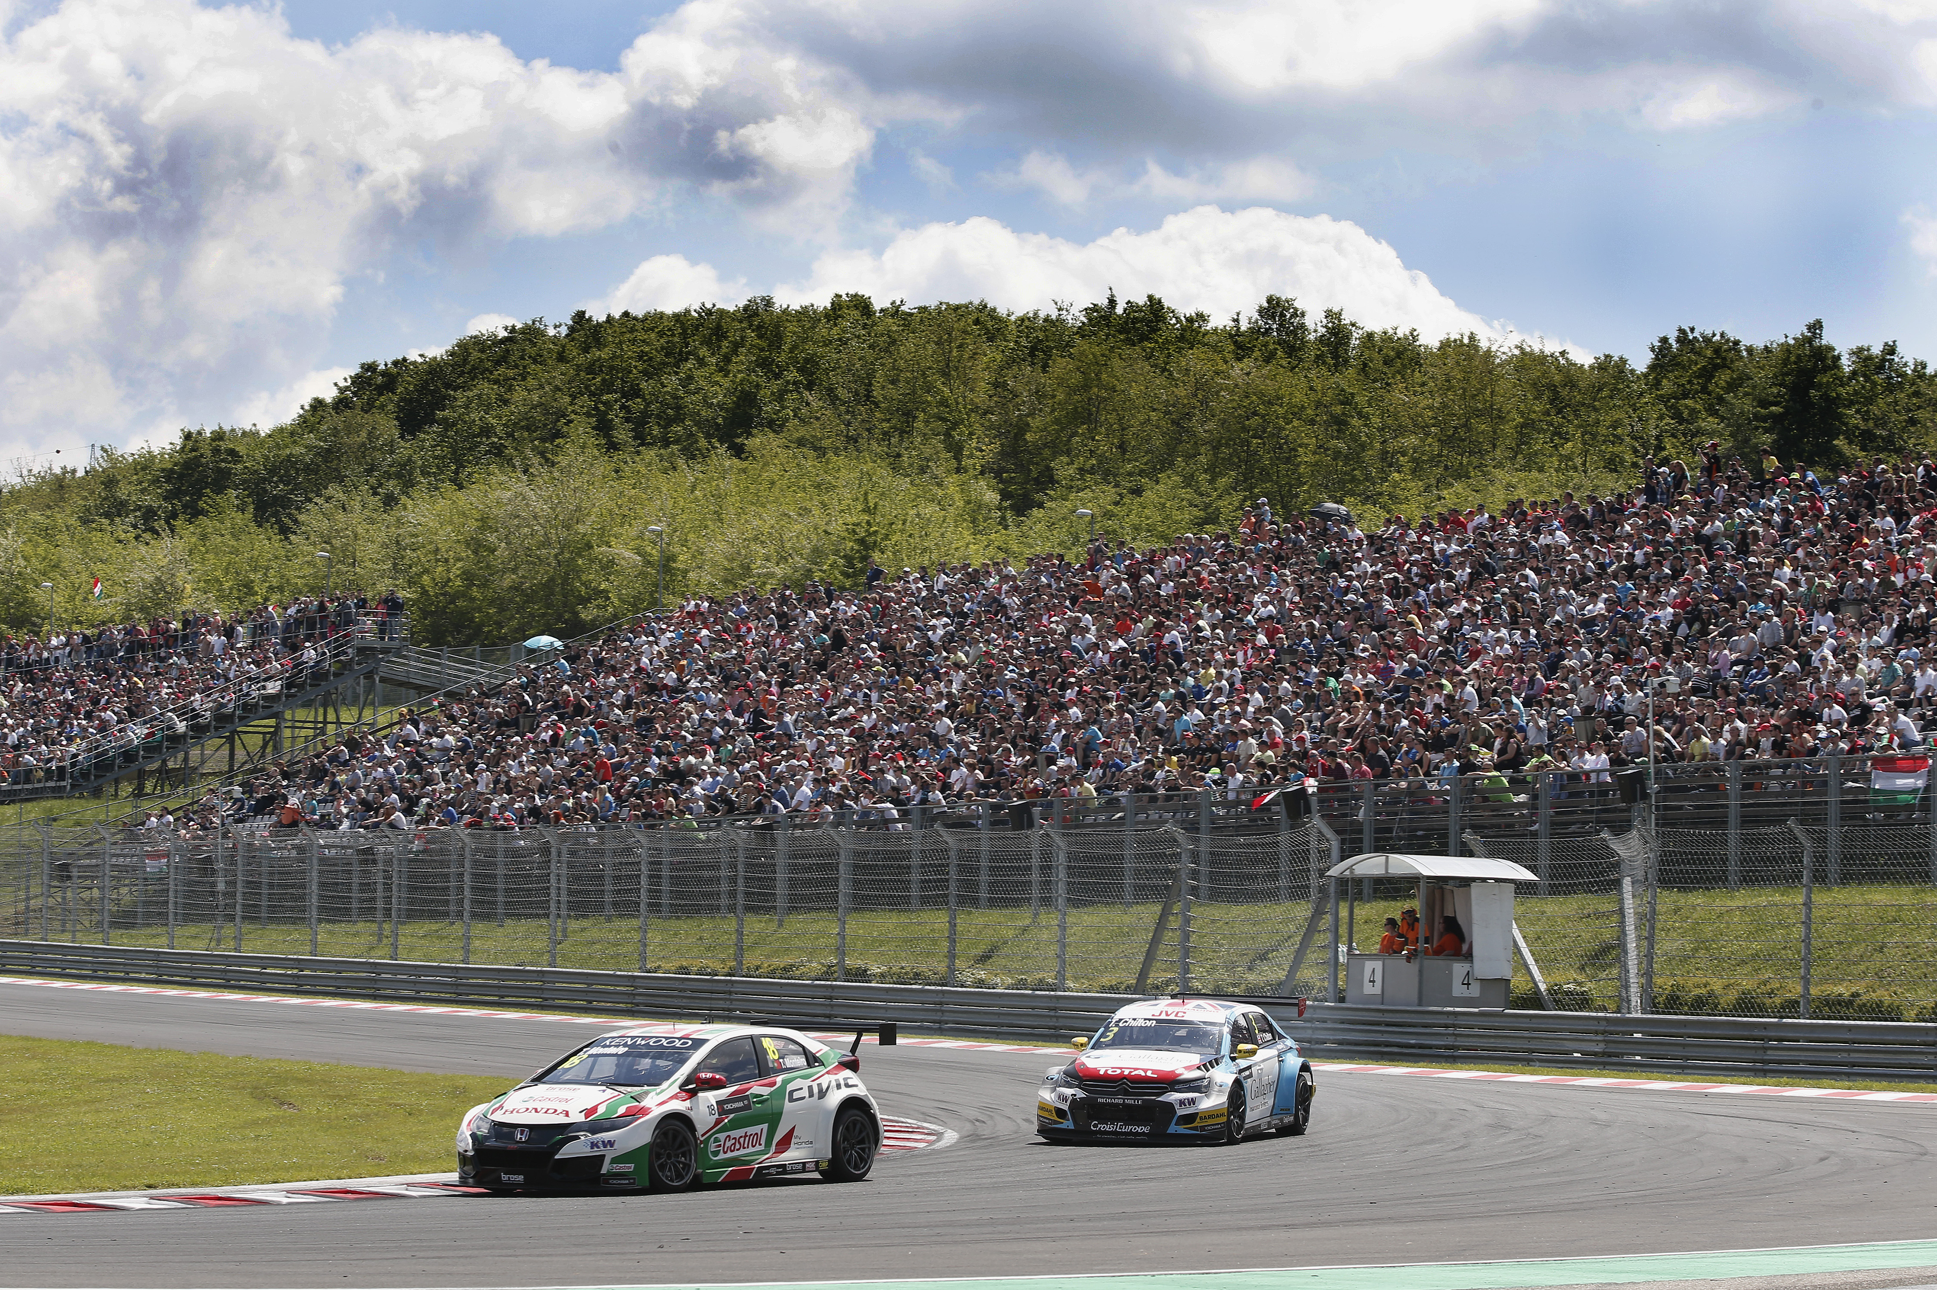
Chilton in hot pursuit of Monteiro

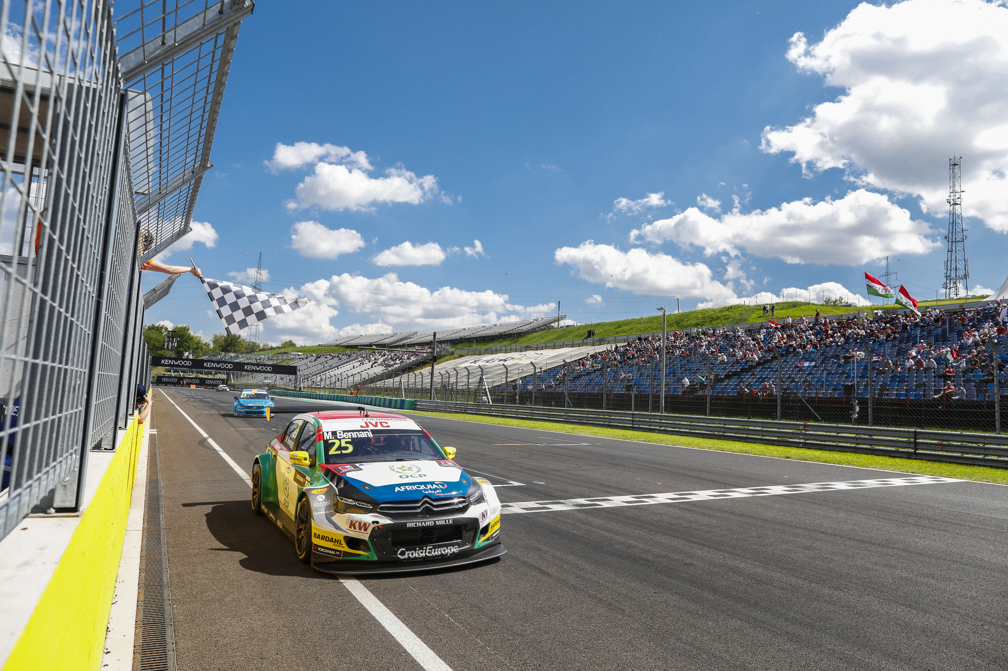
Bennani Wins

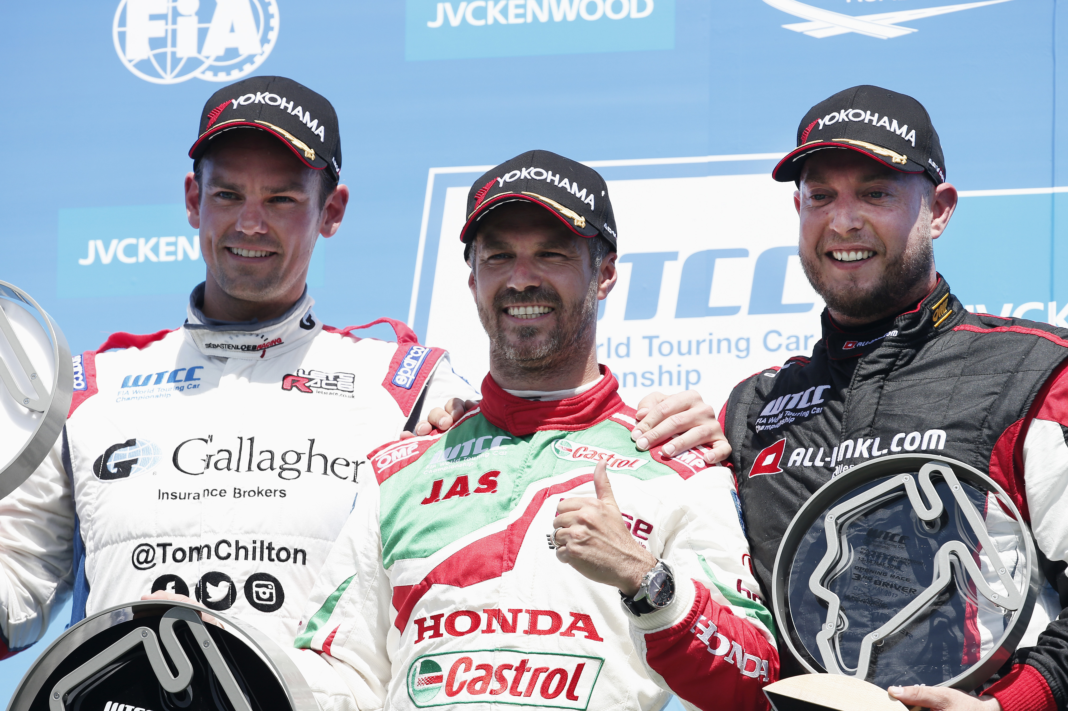
Monteiro wins ahead of Chilton and Huff in Hungary

